**COMSATS University Islamabad**

**Department of Computer Science**

**CSE304 Object Oriented Software Engineering**

**BS(SE) – Section 4A**

LAB Assignment No.2

Project Title

Online Ordering System

Submitted by:

Syed Aown Asghar Raza

FA19-BSE-014

Muhammad Mubashir Rasheed

FA19-BSE-027

Submission Date:

22 – April – 2021

**Class diagram**

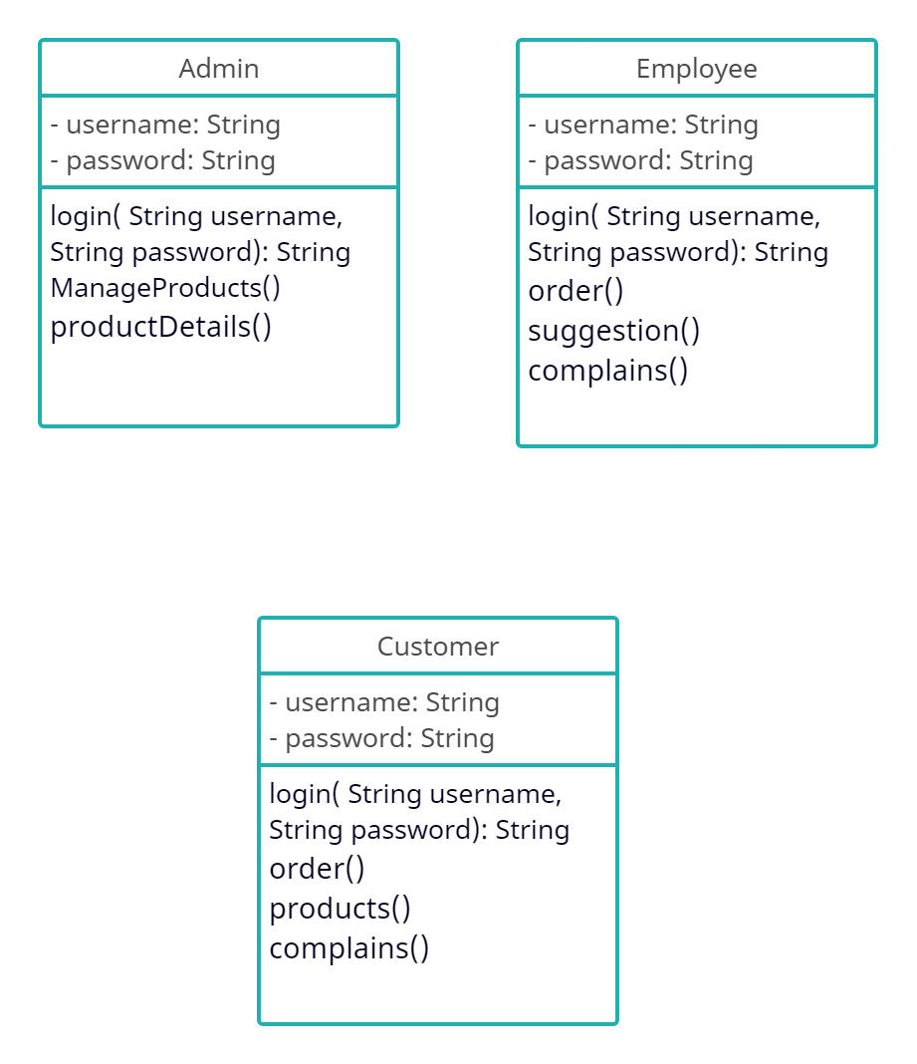

**Admin ( Manage products)**



**Admin ( Manage Employees)**



**Employee ( Approve orders)**



**Employee (Suggestions)**



**Employee (Customer complain)**



**Customer (Products)**



**Customer (Orders)**



**Customer (Complains)**

